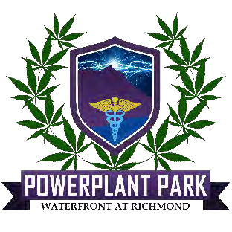
For Immediate Release:

PowerPlant Park-the Future of Cannabis
Seed to Shelf Vertically Integrated Campus Set to Open 4-20-23-Phase I SOLD OUT
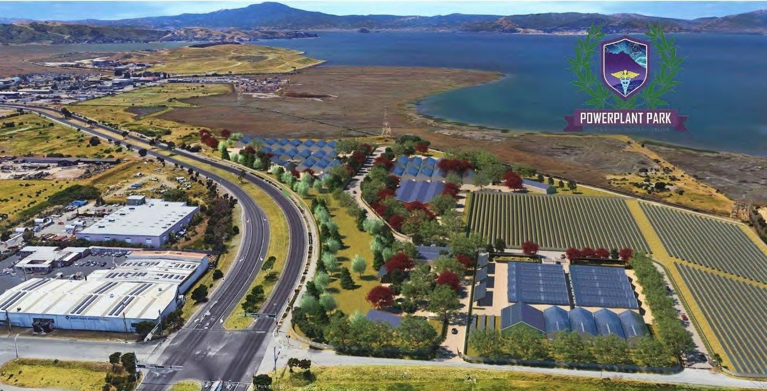
Richmond, Contra Costa County, (4-20-22) …Overlooking the San Francisco Bay a state-of-the-art 18.8- acre cannabis community is beginning to take shape. Now 58 weeks into construction, PowerPlant Park is the first project of its kind in the State of California. The Park has municipal approval for 8 license types, including 59 Tier 2 indoor mixed-light greenhouses, manufactured by the premier US builder, Nexus of Colorado. Each Unit includes over
$250,000 in upgrades and built to the Park’s stringent SOP’s, 1144 plant-sites producing approx. 2,000 lbs. of ultra- premium flower annually.

PowerPlant Park provides the only true turnkey tenancy/ownership model in California, an affordable path towards income, and a perfect fit for all types of cannabis investors, brands, and cultivators alike.

The City of Richmond has already issued a CUP for all 69 buildings including 59 legal addresses required for its tenant- owners to immediately secure a state cultivation license. Tenancy eliminates the 2+ year wait and extraordinary expense to acquire requisite local and state permits and licenses, with no guarantee of regulatory success. Considering the low cost of entry, best-in-class amenities, turnkey opportunities at PowerPlant Park are unrivaled in the State.

PowerPlant Park– CBS 6PM News-Lead Story Before 60 Minutes-4M viewers featuring Richmond’s mayor Tom Butt
PowerPlant Park' Could Make Richmond the Cannabis Capital of Contra Costa County. The City of Richmond could see hundreds of new jobs and millions of dollars for the City….

The Project will open in 3 Phases:

- Phase I consists of 18 Tier 2 indoor mixed-light greenhouses, fully operational by April 2023
- Phase I-A, II & III consists of an additional 44 greenhouses that are currently for sale
- Phase I tenants include brands such as Eve Farms. Nursery operations and exclusive genetics managed by Phinest Cannabis

Sustainability is a key focus at PowerPlant Park. The carbon-negative campus will be powered by the adjacent 2- meg solar farm with Tesla battery storage. On the off-chance batteries run low, (due to extreme weather), the power is backed up through a bilateral connection from the solar farm to PG&E. PowerPlant Park will be the only commercial cannabis operation in the US that is carbon negative and 100% off-grid. The Park has coined it the “GreenGreen New Deal”. Greenhouses Units will be illuminated with LED lights from Fohse. Several commercial growers in California who have switched their light source to Fohse have seen finished yield increases of 15%-25%!

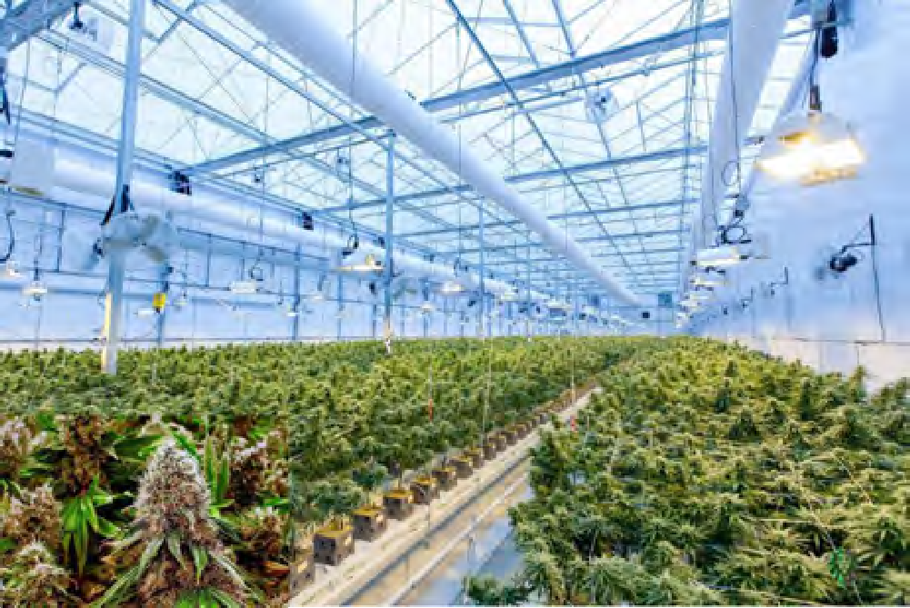
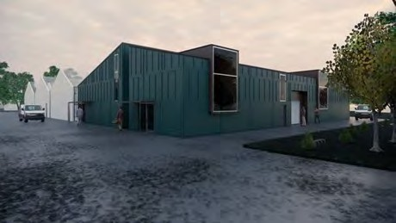

In addition to the Greenhouses, PowerPlant Park will offer a variety of onsite amenities, including:
  - 12,000 sq. ft. of state-of-the-art processing/manufacturing/packaging facilities
  - Medical grade volatile/non-volatile extraction
  - Edible’s kitchen
  - Preroll assembly, (infused menu)
  - Compliant branding and fulfillment services
  - Statewide distribution through a network of wholesale buyers, presold contracts and through planned retail outlets, including delivery, storefront kiosks, and onsite drive-thru facilities
  - Superior tissue culture genetics, including exclusive cultivars that only PowerPlant Park will offer retail/wholesale

About PowerPlant Park

PowerPlant Park is being developed by serial entrepreneur Richard Trieber. Richard was drawn to the cannabis industry when his older son, (at age 7) started having issues in school and was diagnosed with ADHD. Doctors prescribed a cocktail of dangerous psychotropic drugs to his son, but as a worried dad, Richard started doing research on cannabis and how it may treat his condition. After speaking to the president of Medicann and sending his medical records Richards son became the youngest person, (age 13) to receive a doctor’s recommendation for cannabis as medicine. After 30 days, (in small doses) Richard was able to wean his son off the pharmaceutical drugs and saw a dramatic difference in his son’s outward behavior in several different settings. In 2014 Richard decided to start a 700-plant indoor grow, (under Prop 215), eventually starting a successful delivery service that led to his expanded commitment to the cannabis industry. Since then, Richard has raised more than $4M and sold 22 Phase I Greenhouses, (over $11M). These funds have allowed the Park to purchase Phase I, I-A & II land, now pouring foundations and soon buildings will light up Richmond’s Northshore sky.

Please visit PowerPlant Park for more information.

MEDIA CONTACT:
415-233-3131

